**Name:** Mozeb Ahmed Khan

**Roll No:** 20F-0161

**Section:** BS (CS)-6A

**Course:** Web Programming

**Lab No:** 01

**Task 1:**

**Code:**

<!DOCTYPE html>

<html>

<head>

 <title>  First Web Page   </title>

<meta name="viewport" content="width=device-width, initial-scale=1.0">

 <link   src="">

<script>

 </script>

</head>

<body>

<h1>  This is the task 1  </h1>

<h2> Name: Mozeb Ahmed Khan </h2>

<h3> Roll Number: 20F-0161 </h3>

<h4> I am a BS CS student from Fast Nuces university. Currently, I am studying web programming. </h4>

</body>

</html>

**Output:**

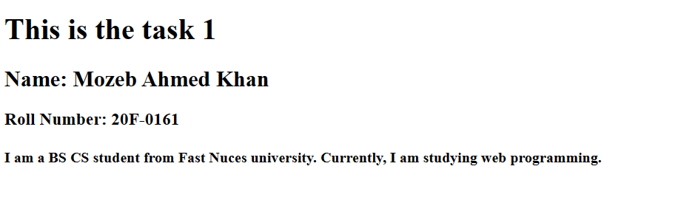

**Task 2:**

**Code:**

<!DOCTYPE html>

<html>

<head>

 <title>  First Web Page   </title>

<meta name="viewport" content="width=device-width, initial-scale=1.0">

 <link   src="">

<script>

 </script>

</head>

<body>

<h1>  This is the task 2  </h1>

<p> <b> This text is bold </b> </p>

<p> <strong> This text is strong </strong> </p>

<p>  This text is big  </p>

<p> <i> This text is italic</i> </p>

<p> <em> This text is emphasized </em> </p>

<p> <tt> This is computer output </tt> </p>

<p>  This is <sub> subscript </sub> and <sup> superscript </sup> </p>

</body>

</html>

**Output:**

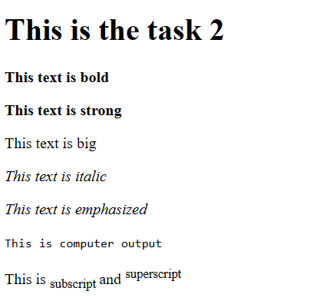

**Task 3:**

**Code:**

<!DOCTYPE html>

<HMTL lang="en">

<head>

  <meta charset="UTF-8">

  <meta name="viewport" content="width=device-width, initial-scale=1.0">

<title> First Web Page </title>

<script>    </script>

<link>    </link>

</head>

<body>

<h1>  This is the task 3  </h1>

<h2> Welcome to fast nuces </h2>

<p> Click on the logo to go to nu official site. </p>

<a href="https://www.nu.edu.pk" alt="Example.com" >

<img  src="fast.png" alt="Ok" width="500cm"height="500cm" />

 </a>

</body>

</html>

**Output:**



**Task 4:**

**Code:**

<!DOCTYPE html>

<HMTL lang="en">

<head>

  <meta charset="UTF-8">

  <meta name="viewport" content="width=device-width, initial-scale=1.0">

<title> First Web Page </title>

<script>    </script>

<link>    </link>

</head>

<body>

<h1>  This is the task 4  </h1>

<h2> Welcome to fast nuces </h2>

<p> Click on the logo to go to nu official site. </p>

<a href="https://www.nu.edu.pk" alt="Example.com" target="blank" >

<img  src="fast.png" alt="Ok" width="500cm"height="500cm" />

 </a>

</body>

</html>

**Output:**





**Task 5:**

**Code:**

<!DOCTYPE html>

<HMTL lang="en">

<head>

  <meta charset="UTF-8">

  <meta name="viewport" content="width=device-width, initial-scale=1.0">

<title> First Web Page </title>

<script>    </script>

<link>    </link>

</head>

<body>

<h1>  HTML Lists  </h1>

<h2>  Unordered List  </h2>

<p> We have books on a variety of languages. </p>

<ul>

<li> Oracle </li>

<li> Java</li>

<li> HTML </li>

<li> CSS </li>

</ul>

<h2>  Ordered List  </h2>

<p> follow these steps to install Java. </p>

<ol>

<li> Download the software.</li>

<li> Extract to folder.</li>

<li> Double click the executable to run.</li>

</ol>

</body>

</html>

**Output:**

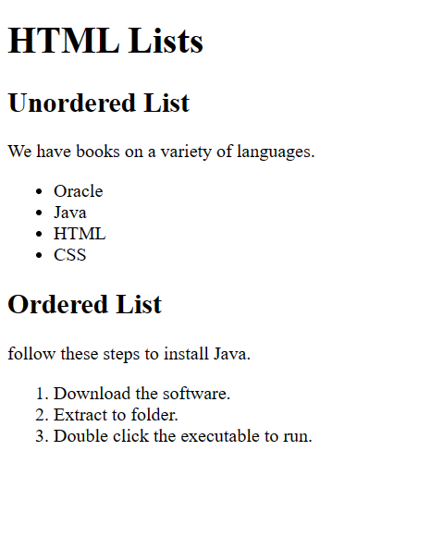

**Task 6:**

**Code:**

<!DOCTYPE html>

<html lang="en">

<head>

  <meta charset="UTF-8">

  <meta name="viewport" content="width=device-width, initial-scale=1.0">

  <title>First Web Page</title>

  <script></script>

  <link></link>

</head>

<body>

  <h1>This is task 6</h1>

  <table border="1" width="300px" height="100px" cellpadding="1px" cellspacing="0px">

    <tbody>

      <tr align="center">

        <td rowspan="3"> <b>April</b></td>

        <td >Rohan</td>

        <td>Subhan</td>

      </tr>

      <tr align="center">

        <td>OS</td>

        <td>WP</td>

      </tr>

      <tr align="center">

        <td>3.0</td>

        <td>4.0</td>

      </tr>

      <tr align="center">

        <td>CN</td>

        <td>OS</td>

        <td>WP</td>

      </tr>

      <tr align="center">

        <td>JavaScript HTML CSS</td>

        <td>Data Structures</td>

        <td>Operating Systems</td>

      </tr>

    </tbody>

  </table>

</body>

</html>

**Output:**

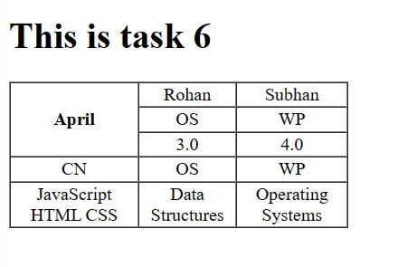

**Task 7:**

**Code:**

<!DOCTYPE html>

<html lang="en">

<head>

  <meta charset="UTF-8">

  <meta name="viewport" content="width=device-width, initial-scale=1.0">

  <title>First Web Page</title>

  <script></script>

  <link></link>

</head>

<body>

  <h1>This is task 7</h1>

  <table border="1" width="300px" height="100px" cellpadding="1px" cellspacing="0px">

    <tbody>

      <tr align="center">

        <td colspan="3"> <b>2022</b></td>

      </tr>

      <tr align="center">

        <td >Rohan</td>

        <td >Mozeb</td>

        <td>Subhan</td>

      </tr>

      <tr align="center">

        <td colspan="2"><b>Fiesta</b></td>

        <td>W.P</td>

      </tr>

      <tr align="center">

        <td colspan="2"><b></b></td>

        <td>3.0</td>

      </tr>

      <tr align="center">

        <td>Blockchain</td>

        <td>Data Mining</td>

        <td>Data Science</td>

      </tr>

    </tbody>

  </table>

</body>

</html>

**Output:**

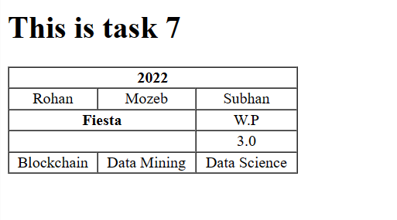

**Task 8:**

**Code:**

<!DOCTYPE HTML>

<HMTL lang="en">

<head>

  <meta charset="UTF-8">

  <meta name="viewport" content="width=device-width, initial-scale=1.0">

<title> First Web Page </title>

<script>    </script>

<link>    </link>

</head>

<body>

<h1> This is my task 8.</h1>

<form action="/submit" method="post">

<label>  Username:  </label>

<input type="text" name="name" value="" size="10" placeholder="username" required><br>

<br>

<label>  Email: </label>

<input type="text" name="name" value="" size="10" placeholder="email" required><br>

<br>

<label>  Password:  </label>

<input type="text" name="password" size="10" value="" placeholder="password" required> <br>

<br>

<label>  Confirm Password:  </label>

<input type="text" name="password" size="10" value="" placeholder="confirm password" required> <br>\

<br>

<input type="submit" name="submit"  value="Submit" placeholder="" > <br>

<input type="reset" name="reset"  value="Reset" placeholder="" > <br>

</form>

</BODY>

</html>

**Output:**

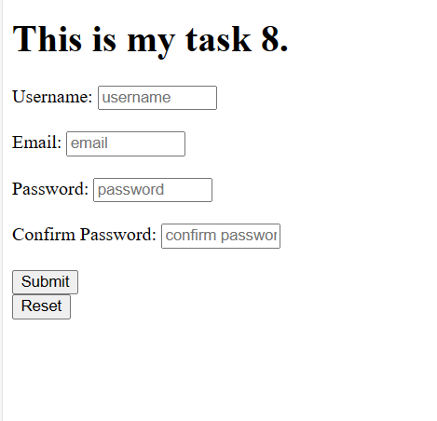

**Task 9:**

**Code:**

<!DOCTYPE HTML>

<HMTL lang="en">

<head>

  <meta charset="UTF-8">

  <meta name="viewport" content="width=device-width, initial-scale=1.0">

<title> Pete's Pizza Delivery</title>

<script>    </script>

<link>    </link>

<style>

    h1, h2, h4, h5, h6, p {

      text-align: center;

    }

    label {

      display: inline-block;

      margin-bottom: 5px;

      margin-right: 2px;

      margin-left: 30px;

      text-align: right;

      width: 250px;

      height: 25px;

      vertical-align: top;

    }

    input {

      width: 350px;

      height: 25px;

      padding: 15px;

      margin-bottom: 10px;

      box-sizing: border-box;

      vertical-align: top;

    }

    input[type="radio"] {

      transform: scale(0.7);

      margin-right: 2px;

      text-align: center;

    }

    br.group {

      clear: both;

    }

    input[type="submit"] {

      width: auto;

      margin-top: 10px;

    }

  </style>

</head>

<body>

<h1> Pete's Pizza Delivery</h1>

<h2> Online Order Form</h2>

<form action="/submit" method="post">

<label for="name">  *Name:  </label>

<input type="text" name="name" id="name" size="10" value="" required>

<label for="tel">  *Tel: </label>

<input type="tel" name="tel" id="tel" size="10" value="" required>

<br class="group">

<label for="address">  *Address:  </label>

<input type="text" name="address" id="address" size="10" value="" required>

<label for="email">  *Email:  </label>

<input type="email" name="email" id="email" size="10" value="" required>

<br class="group">

<label for="townCity">  *Town/city:  </label>

<input type="text" name="townCity" id="townCity" size="10" value=""  required>

<br>

<label for="postcode">  *Postcode:  </label>

<input type="text" name="postcode" id="postcode" size="10" value="" required>

<br>

<p>* required fields</p>

<br>

<h3>

  &nbsp;&nbsp;&nbsp;&nbsp;&nbsp;&nbsp;&nbsp;&nbsp;&nbsp;&nbsp;&nbsp;&nbsp;&nbsp;&nbsp;&nbsp;&nbsp;&nbsp;&nbsp;&nbsp;&nbsp;

  &nbsp;&nbsp;&nbsp;&nbsp;&nbsp;&nbsp;&nbsp;&nbsp;&nbsp;&nbsp;&nbsp;&nbsp;&nbsp;&nbsp;&nbsp;&nbsp;&nbsp;&nbsp;&nbsp;&nbsp;

  &nbsp;&nbsp;&nbsp;&nbsp;&nbsp;&nbsp;&nbsp;&nbsp;&nbsp;&nbsp;&nbsp;&nbsp;&nbsp;&nbsp;&nbsp;&nbsp;&nbsp;&nbsp;&nbsp;&nbsp;

  &nbsp;&nbsp;&nbsp;&nbsp;&nbsp;&nbsp;&nbsp;&nbsp;

Topping

</h3>

<input type="radio" id="margherita" name="Topping" value="margherita">

<label for="margherita">Margherita</label>

<br>

<input type="radio" id="fourseasons" name="Topping" value="fourseasons">

<label for="fourseasons">Four Seasons</label>

<br>

<input type="radio" id="meatfeast" name="Topping" value="meatfeast">

<label for="meatfeast">Meat Feast</label>

<br>

<h3>

  &nbsp;&nbsp;&nbsp;&nbsp;&nbsp;&nbsp;&nbsp;&nbsp;&nbsp;&nbsp;&nbsp;&nbsp;&nbsp;&nbsp;&nbsp;&nbsp;&nbsp;&nbsp;&nbsp;&nbsp;

  &nbsp;&nbsp;&nbsp;&nbsp;&nbsp;&nbsp;&nbsp;&nbsp;&nbsp;&nbsp;&nbsp;&nbsp;&nbsp;&nbsp;&nbsp;&nbsp;&nbsp;&nbsp;&nbsp;&nbsp;

  &nbsp;&nbsp;&nbsp;&nbsp;&nbsp;&nbsp;&nbsp;&nbsp;&nbsp;&nbsp;&nbsp;&nbsp;&nbsp;&nbsp;&nbsp;&nbsp;&nbsp;&nbsp;&nbsp;&nbsp;

  &nbsp;&nbsp;&nbsp;&nbsp;&nbsp;&nbsp;&nbsp;&nbsp;

   Size </h3>

  <input type="radio" id="small" name="Size" value="small">

  <label for="small">Small</label>

  <br>

  <input type="radio" id="medium" name="Size" value="medium">

  <label for="medium">Medium</label>

  <br>

  <input type="radio" id="large" name="Size" value="large">

  <label for="large">Large</label>

  <br>

<h3>

  &nbsp;&nbsp;&nbsp;&nbsp;&nbsp;&nbsp;&nbsp;&nbsp;&nbsp;&nbsp;&nbsp;&nbsp;&nbsp;&nbsp;&nbsp;&nbsp;&nbsp;&nbsp;&nbsp;&nbsp;

  &nbsp;&nbsp;&nbsp;&nbsp;&nbsp;&nbsp;&nbsp;&nbsp;&nbsp;&nbsp;&nbsp;&nbsp;&nbsp;&nbsp;&nbsp;&nbsp;&nbsp;&nbsp;&nbsp;&nbsp;

  &nbsp;&nbsp;&nbsp;&nbsp;&nbsp;&nbsp;&nbsp;&nbsp;&nbsp;&nbsp;&nbsp;&nbsp;&nbsp;&nbsp;&nbsp;&nbsp;&nbsp;&nbsp;&nbsp;&nbsp;

  &nbsp;&nbsp;&nbsp;&nbsp;&nbsp;&nbsp;&nbsp;&nbsp;

   Extras </h3>

<input type="checkbox" id="mushrooms" name="Extras" value="mushrooms">

<label for="mushrooms">Mushrooms </label>

<br>

<input type="checkbox" id="green" name="Extras" value="green">

<label for="green">Green peppers</label>

<br>

<input type="checkbox" id="anchovies" name="Extras" value="anchovies">

<label for="anchovies">Anchovies</label>

<br>

<input type="checkbox" id="cheese" name="Extras" value="cheese">

<label for="cheese">Extra cheese</label>

<br>

<br>

<label for="time">  Preferred delivery time:  </label>

<input type="time" name="time" id="time" size="10" value=""  required>

<br>

<label for="instructions">  Delivery instructions:  </label>

<input type="text" name="instructions" id="instructions" size="10" value="" width="350px" height="100px" fontsize="18px" required>

<br>

<input type="submit" name="submit"  value="Submit order" placeholder="" > <br>

</form>

</BODY>

</html>

**Output:**

**The End.**